**Design Thinking Project Workbook**

**Don't find customers for your product but find products for your customers**

1. **Team**

Team Name: Smart connect

**Team Logo (if any):**



**Team Members:**

1. [P.PhaniTejaswi, Problem identification,8333965338]
2. [M.Srija, Solution overview, 8688066247]
3. [Lavanya Reddy, User researcher , 9949979757]

**2. Problem/Opportunity Domain**

**Domain of Interest:** Our project Telemedicine typically fall under the broader domain of Healthcare Technology or Health.

Description of the Domain: Telemedicine bridges the gap between healthcare providers and patients using technology. With increasing demand for healthcare accessibility, telemedicine enables remote consultations, diagnoses, and treatment management, offering potential improvements in healthcare efficiency. Challenges in this domain include maintaining data security, ensuring reliable connectivity, and integrating telemedicine into traditional healthcare systems.

Why did you choose this domain?: Telemedicine is an area of growing importance due to the global shift towards digital healthcare, driven by the need for better patient access, convenience, and cost efficiency. We believe that innovative solutions can address significant challenges and help improve patient outcomes while optimizing resources.

**3. Problem/Opportunity Statement**

**Problem Statement:** Many patients, especially those in rural or remote areas, face difficulties accessing healthcare services due to physical distance, resource limitations, or the current infrastructure's inefficiencies.

Problem Description: Patients are often unable to receive timely medical consultations, leading to delayed diagnoses, extended suffering, and in some cases, worsening health conditions. The traditional healthcare system is overburdened, making it difficult for many to schedule appointments promptly.

Context (When does the problem occur): This problem arises particularly in under-served communities, during emergencies when quick medical attention is needed, and for patients with chronic conditions requiring frequent check-ups.

Alternatives (What does the customer do to fix the problem): Customers typically travel long distances to visit doctors, rely on over-the-counter medications, or delay medical attention, which can lead to serious complications.

**Customers (Who has the problem most often):** Patients who cannot make time to visit hosipital in their busy schedule or patients in rural, remote areas, people with mobility issues, those with chronic conditions needing frequent consultations, and healthcare providers seeking to manage large patient loads efficiently.

**Emotional Impact (How does the customer feel):** Patients often feel frustrated, anxious, and neglected due to delayed access to medical care. Healthcare providers may feel overwhelmed by the sheer volume of patients they need to manage.

Quantifiable Impact (What is the measurable impact): Increased patient waiting times, higher rates of hospitalization due to delayed diagnosis, financial losses from missed work, and elevated healthcare costs due to complications.

**Alternative Shortcomings (What are the disadvantages of the alternatives):** Traveling long distances is costly and time-consuming, while self-medication or delayed medical attention can worsen health outcomes. Overburdened healthcare facilities result in long waiting times and rushed consultations.

**Any Video or Images to showcase the problem:**

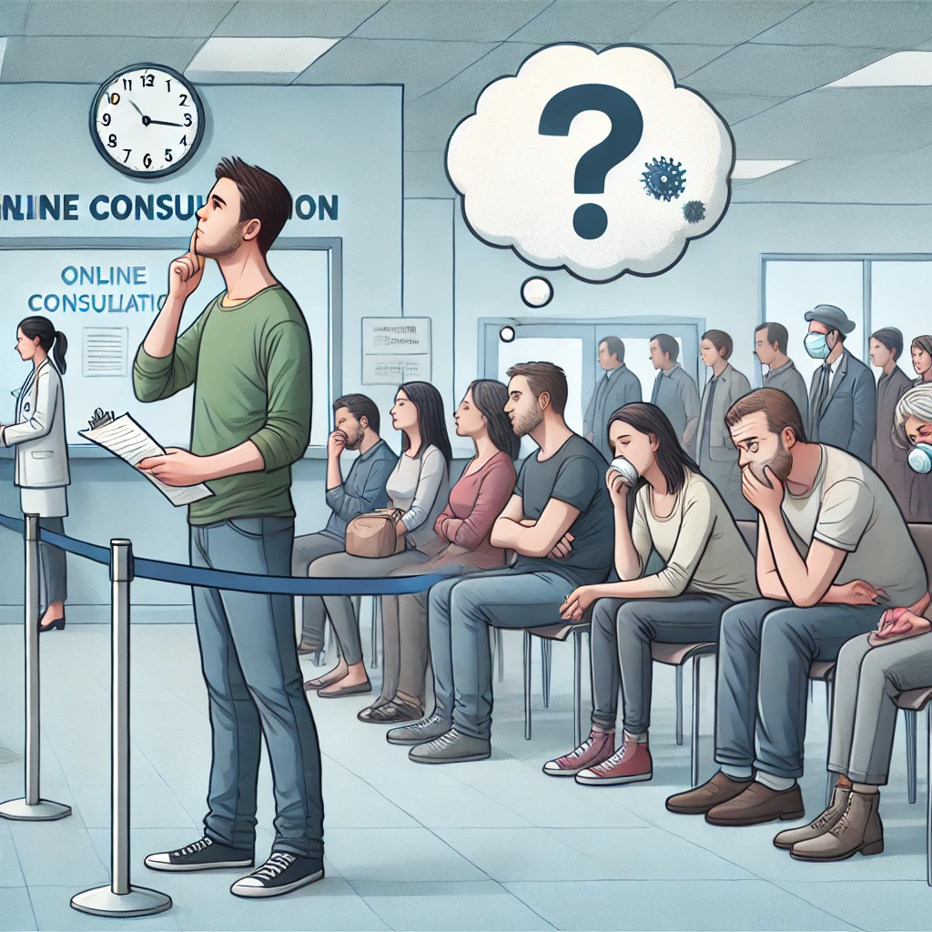

Here is an image representing the challenge of visiting a crowded hospital instead of opting for an online consultation. It highlights the stress and frustration patients may experience in a hospital setting, contrasting with the convenience of telemedicine.

**4. Addressing SDGs**

**Relevant Sustainable Development Goals (SDGs):**

**1) SDG 3: Good Health and Well-being**

**2) SDG 9: Industry, Innovation, and Infrastructure**

**3) SDG 10: Reduced Inequalities**

**How does your problem/opportunity address these SDGs?: By improving access to healthcare through telemedicine, we can enhance health and well-being (SDG 3). The use of technology fosters innovation and improved healthcare infrastructure (SDG 9). Additionally, telemedicine reduces healthcare inequalities by ensuring even remote areas have access to timely medical care (SDG 10).**

**5. Stakeholders**

Answer these below questions to understand the stakeholder related to your project

1. **Who are the key stakeholders involved in or affected by this project?**

• Patients (especially in rural areas)

• Doctors and healthcare providers

• Healthcare facilities

• Telemedicine technology providers

• Government regulatory bodies

• Insurance companies

1. **What roles do the stakeholders play in the success of the innovation?**

• Patients: End-users who benefit from improved access to healthcare.

• Doctors: Provide remote consultations.

• Facilities: Integrate telemedicine services.

• Tech Providers: Ensure platform functionality and security.

• Government: Set regulations and guidelines.

• Insurers: Facilitate coverage for telemedicine services.

1. **What are the main interests and concerns of each stakeholder?**

• Patients: Access to affordable, quality care.

• Doctors: Effective and reliable technology.

• Tech Providers: Ensuring data privacy and system reliability.

1. **How much influence does each stakeholder have on the outcome of the project?**

• Patients and doctors have high interest and engagement.

• Tech providers and governments have high power but varying interest.

1. **What is the level of engagement or support expected from each stakeholder?**

**Patients** (End Users): High engagement is expected from patients, as they will actively use the telemedicine platform for consultations. Their feedback will be crucial for refining the service and ensuring it meets their needs.

**Healthcare Providers** (Doctors, Nurses): High engagement is expected in terms of providing consultations, monitoring patient progress, and offering feedback on usability.

**Developers/Technical Team**: High engagement is essential as they are responsible for building, testing, and maintaining the telemedicine platform.

1. **Are there any conflicts of interest between stakeholders? If so, how can they be addressed?**

**Conflict Between Patients and Healthcare Providers**: Patients may want faster service, while providers need time to ensure quality care.

**Healthcare Providers vs. Developers**: There could be a disconnect between technical feasibility and what healthcare providers want in the platform.

**Telecom Providers vs. Patients**: Rural areas may not have sufficient internet infrastructure. This can be mitigated by partnering with telecom providers early on to ensure network improvements in critical areas or offering offline consultation methods where needed.

1. **How will you communicate and collaborate with stakeholders throughout the project?**

Hold regular meetings with medical professionals for system feedback, progress reports, and suggestions for improvements.

Regular surveys, interviews, and usability testing will be conducted to gather feedback on the telemedicine experience.

Use project management software (such as Jira or Trello) for task tracking and hold daily or weekly stand-up meetings to discuss progress, challenges, and feedback.

1. **What potential risks do stakeholders bring to the project, and how can these be mitigated?**

**Patients**: Low user adoption if the platform is not user-friendly or if internet access is limited. This can be mitigated by focusing on UX design and providing user training or support.

**Healthcare Providers**: If providers feel overburdened by too many consultations, they may disengage.

**Developers**: There’s a risk of delays in platform development if technical challenges arise. Mitigation strategies include an agile development approach and regular testing to catch issues early.

**6. Power Interest Matrix of Stakeholders**

|  |  |  |  |
| --- | --- | --- | --- |
| Stakeholder | Power | Interest | Position/Management Strategy |
| Healthcare Providers (Doctors) | High | High | Manage Closely: Engage them in system development, gather continuous feedback to ensure usability and efficiency. |
| Patients (Urban/Rural) | Medium | High | Keep Informed: Provide regular updates about new features and improvements to ensure adoption. |
| Healthcare Regulators (HIPAA, etc.) | High | Low | Keep Satisfied: Ensure all regulations are met, and compliance is communicated to build trust. |
| Developers and IT Team | High | High | Manage Closely: Involve in decision-making for technology stack, security protocols, and testing. |
| Investors/Stakeholders | High | Medium | Keep Satisfied: Share key metrics like consultations and patient satisfaction to maintain confidence. |
| Insurance Companies | Medium | Low | Monitor: Ensure the system can be integrated with insurance processes without requiring major changes. |
| Support Staff (Admin) | Low | High | Keep Informed: Train them well on system functionality and address their concerns promptly. |

Explanation:

* High Power, High Interest (Doctors, Developers): These are key players whose needs must be closely managed. For doctors, usability and functionality are critical. Developers will ensure system security, compliance, and performance.
* High Power, Low Interest (Regulators): Compliance is essential, but they don't need day-to-day involvement. Keep them satisfied by adhering to regulations and showing security measures.
* Low Power, High Interest (Patients): They are the primary users, and their satisfaction is essential, but they don’t influence technical decisions. Keep them informed and address their feedback.
* Low Power, Low Interest (Support Staff): Ensure they are well-trained and confident in using the system, as they are directly interacting with it.

**7.Empathetic Interviews**

**Conduct Skilled interview with at least 30 citizens/Users by asking open ended questions (What, why/How etc) and list the insights as per the format below**

|  |  |  |
| --- | --- | --- |
| **I need to know**  **(thoughts, feelings, actions)** | **Questions I will ask**  **(open questions)** | **Insights I hope to gain** |
| Thoughts | What do you think about the current healthcare system? | Understand their views on existing problems or benefits of the healthcare system. |
|  | What are your expectations from a new healthcare app? | Identify user expectations for a digital healthcare solution. |
|  |  |  |
| Feelings | How do you feel when accessing healthcare services online? | Gauge emotional experiences (positive or negative) with online healthcare platforms. |
|  | Why do you feel the current system works or doesn’t work for you? | Discover the frustrations or satisfactions users feel. |
|  |  |  |
| actions | How do you currently manage your health information? | Learn about current practices and tools users employ to track their health. |
|  | How would you prefer to interact with healthcare providers? | Understand preferred communication channels and behaviors users wish to engage in. |
|  |  |  |

**SKILLED INTERVIEW REPORT**

**(Examples are given. Erase them and fill with your user information.)**

|  |  |  |
| --- | --- | --- |
| **User/Interviewee** | **Questions Asked** | **Insights gained (NOT THEIR ANSWERS)** |
| Sanjana,  Student | What are your challenges with booking medical appointments online? | Many users find booking systems complicated and prone to errors or delays. |
| Priya P, Parent | How do you manage your family's health needs digitally? | arents struggle to find a centralized solution that allows tracking for all family members. |
| Alex K,  Engineer | What are your feelings about data privacy in healthcare apps? | Users are concerned about the security and confidentiality of their personal health data. |

**Key Insights Gained:**

* **Users value security and privacy in healthcare applications, with a preference for platforms that ensure data protection.**
* **Many users desire simpler, more intuitive appointment booking systems to minimize frustration.**

**Empathy Map**

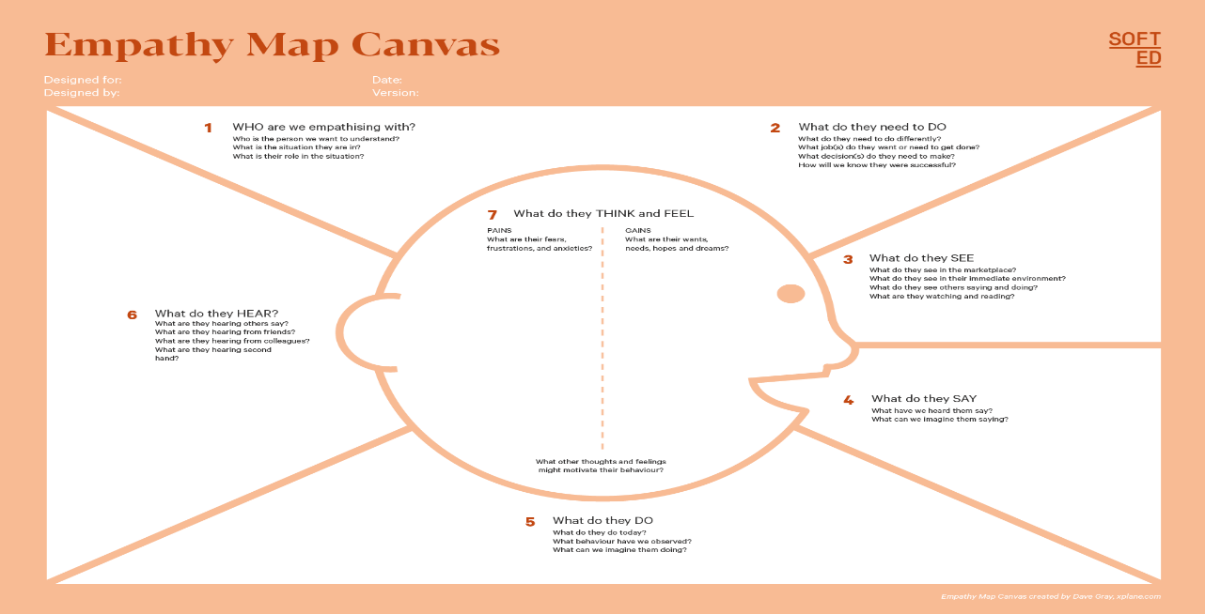

They hear from peers and online reviews about the best healthcare apps. They also hear advertisements about telemedicine and digital health solutions. They might get advice from doctors or tech-savvy friends about which platforms are most effective.

Who is your Customer Segment:

Idea/Innovation Title:

Designed By:

Date of Submission:

They fear mismanagement of their health data, find existing systems time-consuming, and worry about appointment delays.

They desire a simple, secure app that offers easy appointment booking, secure storage of health data, and quick access to healthcare providers.

Your Answer:

They need to book medical appointments, track health records, and receive timely reminders. Success for them means completing these tasks quickly and efficiently.

They see multiple healthcare apps and digital platforms with varying degrees of complexity. They notice the rise of telemedicine and online consultations. They also see other users sharing experiences on social media and review platforms.

Your Answer:

They use a variety of healthcare apps but often switch when they encounter issues. They regularly track their own and their family’s health but tend to abandon apps that are too complicated or unreliable.

**8. Empathy Map**

1. **Who is your Customer?**

**Our primary customers are patients seeking medical consultations through a telemedicine platform.**

**Key points:**

* **Customer Profile: Adults aged 25-60, likely working professionals or parents, tech-savvy, and health-conscious.**
* **Goals and Needs: They need convenient access to healthcare services, timely consultations, and a platform that maintains their privacy and security.**
* **Context of Interaction: Users will interact with the telemedicine solution from home or work using their smartphones or computers, often during busy schedules.**

1. **Who are we empathizing with?**

**We are focusing on patients who require medical advice but may not have time for in-person visits.**

**Key points:**

* **User Characteristics: They are generally health-conscious, value their time, and prioritize convenience. They may have various health concerns ranging from chronic illnesses to minor ailments.**
* **Goals and Challenges: Their goals include quick access to medical advice, continuity of care, and ease of use. Challenges include long wait times, difficulty scheduling appointments, and concerns about the quality of virtual care.**
* **Broader Situation: Many are balancing work, family, and personal health, making in-person visits less feasible.**

1. **What do they need to DO?**

**Users need to perform specific tasks to engage with the telemedicine platform effectively.**

**Key points:**

* **Tasks/Actions: Users need to create an account, schedule appointments, and attend video consultations.**
* **Decisions: They must decide which healthcare provider to consult, how to manage their schedules, and what information to share with doctors.**
* **Defining Success: Success is defined by receiving timely medical advice, satisfaction with the consultation, and improvement in health outcomes.**

1. **What do they SEE?**

**Users interact with various visual elements in their environment and on the platform.**

**Key points:**

**Visual Environment: Users see their home or workplace environment, often in a state of busyness or distraction.**

**Trends/Competitors: They may notice competing telemedicine services, advertising for quick access to care, and promotions from local clinics.**

**Influence of Visuals: Attractive, user-friendly interfaces make them more likely to engage; cluttered or confusing designs can discourage use.**

1. **What do they SAY?**

**This section captures user expressions in conversations and feedback about their experiences.**

**Key points:**

**Expressions About Problems: Users might express frustration with long wait times for in-person appointments and concerns about access to specialists.**

**Goals/Frustrations: They often voice a desire for convenience and quick resolutions for health issues, alongside concerns about the efficacy of virtual visits.**

**Feedback: During interviews, users may say they appreciate the ease of scheduling and the comfort of attending consultations from home.**

1. **What do they DO?**

**This section outlines the observable behaviors of users while interacting with the platform.**

**Key points:**

**Observable Actions: Users search for healthcare providers online, read reviews, schedule appointments, and follow up with healthcare advice.**

**Habits/Routines: Many users may regularly use health apps or websites to manage their health and may often consult medical professionals for advice.**

**Problem-Solving: Users might research symptoms online, engage in self-diagnosis, or seek alternative remedies before consulting a healthcare professional.**

1. **What do they HEAR?**

**This area addresses the external influences that affect users' decisions and experiences.**

**Key points:**

* **Information from Others: Users often hear recommendations from friends, family, or colleagues about which telemedicine services to use.**
* **Media Exposure: They consume content from health-related blogs, social media, and advertisements promoting the benefits of telemedicine.**
* **Influencers: Medical professionals or health influencers may guide their behavior through endorsements or information shared on digital platforms.**

1. **What do they THINK and FEEL?**

**This section delves into the emotions and motivations behind user behaviors.**

**Key points:**

**Fears/Concerns: Users may fear inadequate care through telemedicine, privacy concerns, or miscommunication with healthcare providers.**

**Motivations/Desires: They desire health empowerment, convenience, and quick access to reliable information and services.**

**Thoughts/Feelings Alignment: Positive experiences with telemedicine can boost their confidence in using technology for health management.**

1. **Pains and Gains**

**This section focuses on user frustrations and the benefits they seek from the telemedicine platform.**

**Key points:**

**Main Pain Points: Users struggle with accessing timely care, fear of technology failing during consultations, and navigating complex healthcare systems.**

**Easier/Fulfilling Life: They seek hassle-free scheduling, prompt medical advice, and the ability to manage health without long wait times.**

**Desired Benefits: Users hope to achieve greater health management efficiency, cost savings, and improved access to specialist care through the telemedicine platform.**

**9. Persona of Stakeholders**

**Persona1**

**Stakeholder Name: smart connect team**

**Demographics: • Age: 25-45**

**• Gender: Male/Female**

**• Income: Middle to high income**

**• Location: Urban areas**

**• Occupation: Full-time professionals (e.g., corporate jobs, entrepreneurs)**

**Goals: • To receive timely medical care without interrupting work or daily schedules.**

**• To manage health effectively despite a busy lifestyle.**

**Challenges: • Difficulty scheduling in-person doctor visits due to work commitments.**

**• Long wait times and inconvenience of commuting to clinics.**

**Aspiration: To have quick and easy access to healthcare when needed, minimizing disruption to professional and personal life.**

**Needs: Convenient access to healthcare through digital platforms, flexibility in appointment scheduling, and clear, secure communication with doctors.**

**Pain Points: • Difficulty managing health appointments with a busy schedule.**

**• Frustration with long wait times for appointments.**

**Storytelling: Sarah, a 32-year-old marketing manager, finds it difficult to fit doctor visits into her packed workdays. Between meetings and deadlines, taking time off for a clinic appointment feels like a luxury she cannot afford. Telemedicine becomes the perfect solution, offering her the flexibility to consult with her doctor during a lunch break or late in the evening, allowing her to stay on top of her health without sacrificing work productivity.**

**Sample:**

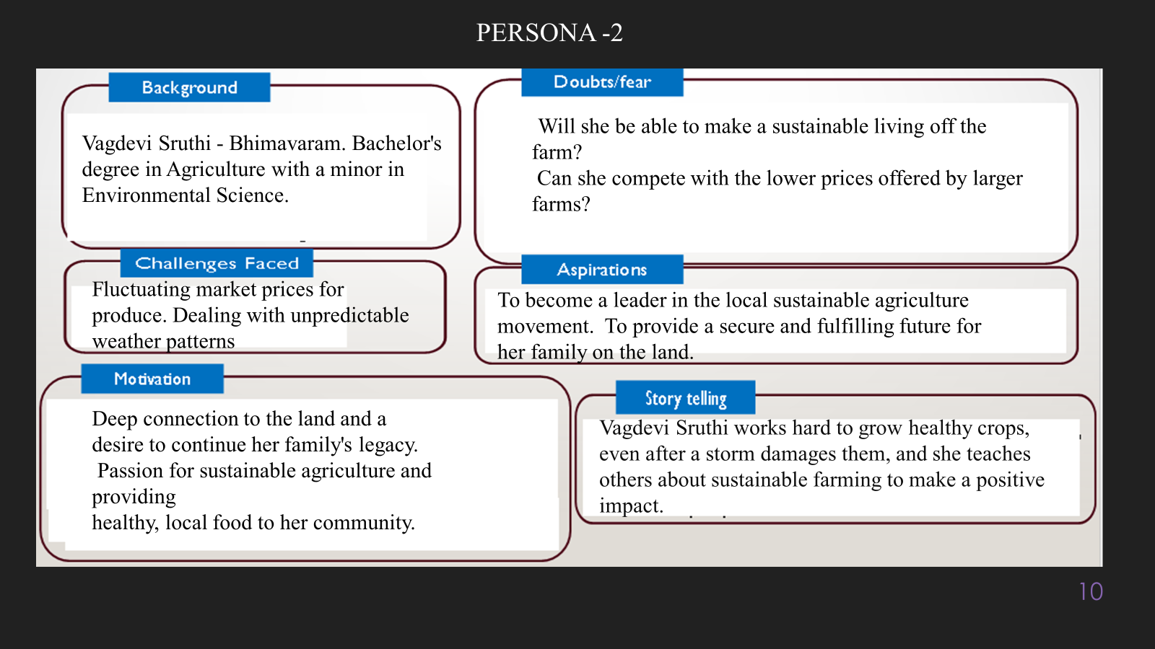

**10. Look for Common Themes, Behaviors, Needs, and Pain Points among the Users**

Analyse the data from your affinity diagram to uncover recurring patterns among your users, helping you better understand their expectations and challenges.

**Common Themes:**

**• Seeking Flexibility:**

* **Users, particularly working professionals, frequently opt for flexible consultation times that align with their schedules. This is reflected in their preference for evening or lunchtime appointments.**

**• Technology Comfort & Adaptation:**

* **While younger, tech-savvy users adapt quickly to digital healthcare, others (elderly and rural users) need more assistance with telemedicine platforms, showing the divide in tech comfort.**

**Common Behaviors:**

**• Reluctance from Older Adults:**

* **Older adults often display hesitation in using technology, relying on caregivers or family members to assist them in setting up telemedicine appointments, highlighting behavioral patterns that differ from younger, tech-savvy users.**

**• Balancing Convenience and Trust:**

* **While telemedicine’s convenience is a major draw, users also actively seek reassurance from their healthcare providers about the quality of care, often requesting follow-ups or physical visits if their health issue seems complex.**

**Common Needs:**

**• User-Friendly Interface:**

* **Both elderly and tech-averse users need simple, intuitive interfaces to navigate telemedicine platforms with ease, without requiring technical knowledge.**

**• Reliable Connectivity:**

* **For rural patients, stable internet access is a crucial need, as poor connectivity limits their ability to benefit from telemedicine services.**

**Common Pain Points:**

**• Difficulty Using Technology:**

* **Elderly users and some rural patients experience frustration with complex telemedicine platforms. Lack of familiarity with technology often leads to confusion or requires assistance from others.**

**• Limited Internet Access:**

* **Rural patients struggle with unstable or slow internet, making video consultations difficult or impossible, which leads to dissatisfaction with telemedicine.**

**• Perceived Lower Quality of Care:**

* **Many users feel that virtual consultations lack the thoroughness of physical exams, leading to concerns about the diagnosis and treatment quality provided via telemedicine.**

**11. Define Needs and Insights of Your Users**

**User Needs:**

**Convenient Access to Healthcare:**

**Functional Need: Users require a platform that enables them to consult with healthcare professionals from their homes or workplaces, without the need to visit a clinic or hospital physically.**

**Time Efficiency:**

**Functional Need: Users expect flexible scheduling options that fit into their daily routines, avoiding long wait times and travel time.**

**Emotional Need: Users want to save time and reduce the stress of fitting medical appointments into their busy schedules.**

**Security and Privacy:**

**Functional Need: Users need assurance that their medical data is securely stored and handled according to regulatory standards (e.g., HIPAA compliance), especially when using online platforms.**

**Reliable Technology and Connectivity:**

**Functional Need: Users, particularly in rural areas, need a telemedicine solution that can work smoothly with limited internet bandwidth or connectivity.**

**Personalized Care:**

**Functional Need: Users want consultations that feel personalized, even in a virtual setting, where their specific medical concerns are addressed thoroughly.**

**Emotional Need: Users need to feel heard and understood by their doctors, not rushed through a standard virtual consultation.**

**User Insights: Flexibility is a Top Priority:**

**Insight: Many users, especially working professionals and caregivers, highly value the flexibility that telemedicine provides in terms of scheduling consultations at their convenience. This suggests that platforms offering flexible appointment times (e.g., evenings or weekends) would attract more users. Busy patients are motivated by the opportunity to consult a doctor without taking time off work or disrupting their daily lives.**

**Trust in Technology is Uneven:**

**Insight: While younger, urban users quickly adapt to telemedicine, older adults and rural users face barriers in using digital health solutions due to unfamiliarity with technology. However, once they overcome the technical hurdles (with the help of family members or caregivers), they appreciate the convenience. This highlights the need for simple, user-friendly platforms with guided support for less tech-savvy individuals.**

**Telemedicine Appeals Most to Time-Sensitive Users:**

**Insight: Users who are time-sensitive (e.g., parents managing children’s schedules or professionals with demanding jobs) are the most likely to adopt telemedicine. For them, the primary motivation is the time saved by avoiding clinic visits. They prefer quick, efficient appointments that fit seamlessly into their busy lives, suggesting that telemedicine platforms need to streamline the consultation process without compromising on care quality.**

**Connectivity Issues Create Barriers in Rural Areas:**

**Insight: Rural users often experience frustration with poor internet connectivity, which can disrupt telemedicine consultations. This technical barrier discourages use and creates dissatisfaction. Telemedicine platforms that offer low-bandwidth solutions (e.g., phone consultations) could better serve this demographic.**

**12. POV Statements**

**POV Statements:**

* [User] needs a way to [need] because [insight].

|  |  |  |  |
| --- | --- | --- | --- |
| PoV Statements | Role-based or Situation-Based | Benefit (Way to Benefit) | PoV Questions |
| Rural patients need a way to access healthcare remotely because poor internet connectivity makes it difficult. | Situation-Based | More reliable access to healthcare services without physical travel. | What can we design that will enable rural patients to consult doctors despite poor internet connections? |
| Elderly users need a simple, user-friendly platform because they struggle with complex technology interfaces. | Role-Based | Easier navigation of healthcare services, leading to higher adoption. | How can we design a telemedicine platform that’s easy for elderly users to navigate on their own? |
| Busy professionals need flexible appointment times because they have demanding work schedules. | Role-Based | Better integration of healthcare into their daily routines. | How can we design telemedicine services that fit seamlessly into the workday of busy professionals? |
| Chronic illness patients need continuity of care because they prefer to maintain long-term relationships with doctors. | Role-Based | Improved long-term health management with trusted physicians. | How can we design a telemedicine system that allows patients to maintain relationships with specific healthcare providers over time? |
| Parents need quick consultations for their children because they have to manage family schedules. | Role-Based | More time-saving healthcare solutions for busy families. | What can we design that provides fast access to pediatric care within tight family schedules? |
| Users need reassurance of privacy and security because they are concerned about sharing sensitive medical data. | Situation-Based | Increased trust and willingness to use telemedicine services. | How can we design a system that clearly demonstrates strong privacy and data security protocols for users? |
| Patients with mobility issues need to consult doctors from home because traveling to hospitals is challenging. | Role-Based | Increased access to healthcare without the burden of travel. | What can we design that enables people with mobility issues to easily access all their healthcare needs from home? |
| Young, tech-savvy users need a fast and seamless experience because they are used to instant solutions. | Role-Based | Smoother, quicker access to healthcare services that fit their digital habits. | How can we design a telemedicine platform that feels fast and intuitive for young, tech-savvy users? |
| Users in remote areas need access to specialists because traveling to urban centers for specialty care is costly. | Situation-Based | More affordable and convenient access to specialized medical care. | How can we design a telemedicine platform that connects remote users with specialized healthcare providers without the need for travel? |
| Healthcare providers need a way to manage virtual consultations efficiently because they struggle with workload balance. | Role-Based | Better management of time and resources, leading to improved patient outcomes. | How can we design a telemedicine platform that helps healthcare providers balance in-person and virtual consultations efficiently? |

**13. Develop POV/How Might We (HMW) Questions to Transform Insights/Needs into Opportunities for Design**

Turn your user needs and insights into actionable opportunities by framing them as "How Might We" (HMW) questions. These questions will spark creative problem-solving and guide your innovation process.

1. **How Might We: Based on the needs and insights you've identified, create open-ended questions starting with "How might we...?" These questions should aim to solve user pain points, enhance the experience, or address specific needs.**

**Examples:**

* **User Need: "Users need a quicker way to access customer support."**
  + **HMW Question: "How might we create a more efficient and accessible customer support system?"**
* **Insight: "Users feel overwhelmed by too many options."**
  + **HMW Question: "How might we simplify decision-making for our users?"**

**Task:**

**Write 3-5 "How Might We" questions based on your analysis of user needs and insights. These questions should challenge you to think of innovative solutions that can address user problems in meaningful ways.**

**This task encourages participants to think creatively about solving user problems, transforming challenges into opportunities for innovation.**

|  |  |
| --- | --- |
| User Need/Insight | "How Might We" Question |
| Users need a reliable way to communicate with healthcare providers remotely, even in areas with poor internet connectivity. | **How might we improve telemedicine access for users in areas with limited or unstable internet connections?** |
| Users feel disconnected and impersonal during virtual consultations, affecting their overall experience. | **Users feel disconnected and impersonal during virtual consultations, affecting their overall experience.** |
| Users need quick access to their health data and treatment history for more informed decision-making. | **How might we simplify the way users access and manage their health records through telemedicine platforms?** |

**14. Crafting a Balanced and Actionable Design Challenge**

The Design Challenge Should Neither Be Too Narrow Nor Too Broad and It Should Be an Actionable Statement with a quantifiable goal. It should be a culmination of the POV questions developed.

**Design Challenge:** [Actionable Statement]

Design an intuitive telemedicine platform that enhances patient-provider interactions by offering personalized experiences, even in areas with limited internet connectivity, and simplifies access to health records, aiming to increase patient satisfaction by 25% within the first year.

**15. Validating the Problem Statement with Stakeholders for Alignment**

Ensure your problem statement accurately represents the needs and concerns of your stakeholders and users. This involves gathering feedback from these groups to confirm that the problem is relevant and significant from their perspective. By validating early, you can refine the problem statement to better align with real-world challenges, ensuring your solution addresses the correct issues.

**Validation Plan:**

**1. Identify Key Stakeholders:**

* **Patients: The primary users of telemedicine services, including those in rural areas or with limited access to in-person care.**
* **Healthcare Providers: Doctors, nurses, and other medical professionals who use telemedicine platforms to interact with patients.**
* **Administrators and IT Support Staff: Those responsible for managing the telemedicine system, ensuring it runs smoothly and meets compliance requirements.**
* **Regulatory Bodies: Organizations ensuring that telemedicine practices follow healthcare regulations.**

**2. Stakeholder Engagement Methods:**

* **Surveys and Questionnaires: Distribute surveys to patients and healthcare providers to gather insights about their current telemedicine experiences, challenges, and needs.**
* **Interviews: Conduct in-depth interviews with a sample of stakeholders, particularly providers and patients from both urban and rural settings, to understand their concerns and preferences.**
* **Focus Groups: Organize virtual or in-person focus groups that bring together stakeholders to discuss specific issues related to the problem statement, such as accessibility, personalization, and usability of telemedicine services.**
* **Direct Feedback on Problem Statement: Share the current problem statement with stakeholders and ask for their feedback, ensuring it reflects their real-world challenges.**

**3. Validate Key Assumptions:**

* **Test Assumption 1: Is the limited internet connectivity a significant barrier for rural patients? Validate through patient interviews and provider feedback in rural areas.**
* **Test Assumption 2: Do users feel that telemedicine lacks personalization, and does this impact satisfaction? Assess through patient surveys and feedback during focus groups.**
* **Test Assumption 3: Is access to health records and data integration a pain point for users and providers? Evaluate by interviewing healthcare professionals and patients to identify their struggles with existing systems.**

**4. Iterate on the Problem Statement:**

**Based on the feedback received:**

* **Refine the language to include specific pain points mentioned by stakeholders.**
* **Adjust goals or objectives if stakeholders highlight new priorities or overlooked issues.**
* **Validate any newly incorporated insights with stakeholders through a second round of surveys or interviews to ensure alignment.**

**5. Quantitative Validation:**

* **Analyze Survey Data: Use quantitative methods to evaluate whether the majority of stakeholders align with the problem statement. For example, if 70% of patients say that internet issues prevent them from accessing telemedicine, this validates a key portion of the problem statement.**
* **Metrics of Alignment: Define a benchmark where, for example, 80% of stakeholder feedback must support the relevance of the identified problem areas.**

**6. Timeline and Feedback Loops:**

* **Initial Feedback Gathering (Weeks 1-2): Distribute surveys, conduct interviews, and organize focus groups.**
* **Data Analysis and Refinement (Weeks 3-4): Analyze the feedback and refine the problem statement based on validation insights.**
* **Second Validation Loop (Weeks 5-6): Share the updated problem statement for final stakeholder feedback, ensuring full alignment.**

**Stakeholder/User Feedback (Min. 10 Stakeholders/Experts):**

|  |  |  |  |
| --- | --- | --- | --- |
| Stakeholder/User | Role | Feedback on Problem Statement | Suggestions for Improvement |
| Dr. Sarah Lee | **Primary Care Physician** | Yes, the problem resonates, especially regarding the impersonal nature of virtual care. | Suggest focusing more on integrating human elements like facial expressions or tone recognition in the platform. |
| John Patel | **Telemedicine Platform Admin** | Resonates with the connectivity issues and health record access struggles. | Consider adding language about the security of health records and data protection as a priority. |
| Rural Health Group | **Patient Advocacy Organization** | Agrees with the connectivity challenges in rural areas; it’s a major access barrier. | Focus more on the affordability of telemedicine services alongside connectivity to address economic disparities. |
| Dr. Emily Carter | |  | | --- | | **Psychiatrist** |  |  | | --- | |  | | The statement feels relevant, especially in mental health, where personalization is key. | Consider exploring how to build rapport and trust virtually, since it's harder in mental health consultations. |
| Mary Gonzalez | **Patient in Rural Area** | Connectivity issues are a major problem for accessing telemedicine services. | Suggest solutions related to offline features or low-bandwidth options to improve access in low connectivity zones. |
| Dr. Rachel Kim | **Pediatrician** | Problem resonates in terms of parents' struggles to access records quickly. | Emphasize the need for faster, mobile-friendly access to pediatric health data for parents on-the-go. |
| Ramana | **Elderly Patient** | The problem resonates, especially around usability and lack of personalization. | Suggest simplifying telemedicine platforms to be more senior-friendly and accessible for older adults. |
| Jane Smith | **Nurse Practitioner** | Agrees that health data access is often a pain point for both providers and patients. | Include more emphasis on the integration of health records from various sources to create a seamless experience. |

**16. Ideation**

**Ideation Process:**

|  |  |  |  |
| --- | --- | --- | --- |
| Idea Number | Proposed Solution | Key Features/Benefits | Challenges/Concerns |
| Idea 1 | **[Brief description of solution]** | **[What are the key benefits of this solution?]** | **[What challenges or concerns exist?]** |
| Idea 2 | **[Brief description of solution]** | **[What are the key benefits of this solution?]** | **[What challenges or concerns exist?]** |
| Idea 3 | **[Brief description of solution]** | **[What are the key benefits of this solution?]** | **[What challenges or concerns exist?]** |
| Idea 4 | **[Brief description of solution]** | **[What are the key benefits of this solution?]** | **[What challenges or concerns exist?]** |
| Idea 5 | **[Brief description of solution]** | **[What are the key benefits of this solution?]** | **[What challenges or concerns exist?]** |

**17. Idea Evaluation**

Evaluate the Idea based on 10/100/1000 grams

|  |  |  |  |  |  |  |  |  |
| --- | --- | --- | --- | --- | --- | --- | --- | --- |
| Idea | | Impact (10/100/1000 grams) | | Feasibility (10/100/1000 grams) | | Alignment (10/100/1000 grams) | | Total Weight |
| AI-Assisted Diagnostics | | **1000** | | **1000** | | **1000** | | **2000** |
| |  | | --- | | **Remote Monitoring for Chronic Diseases** |  |  | | --- | |  | | | **1000** | | **1000** | | **1000** | | **3000** |
| Enhanced Data Security Measures | | **100** | | **1000** | | **1000** | | **2100** |
| Internet Connectivity Solutions for Rural Areas | | **1000** | | **100** | | **1000** | | **2100** |
| Multilingual Support for Diverse Communities | | **100** | | **1000** | | **1000** | | **2100** |
| E-Prescription Services | | **100** | | **1000** | | **1000** | | **2100** |
| Virtual Health Education Sessions | | **100** | | **1000** | | **1000** | | **2100** |
| Telemedicine Platform Integration with Wearables | | **1000** | | **100** | | **1000** | | **2100** |
| Idea | | Impact (10/100/1000 grams) | | Feasibility (10/100/1000 grams) | | Alignment (10/100/1000 grams) | | Total Weight | | |
| Idea 1 | | **[Assign weight]** | | **[Assign weight]** | | **[Assign weight]** | | **[Sum of weights]** | | |
| Idea 2 | | **[Assign weight]** | | **[Assign weight]** | | **[Assign weight]** | | **[Sum of weights]** | | |
| Idea 3 | | **[Assign weight]** | | **[Assign weight]** | | **[Assign weight]** | | **[Sum of weights]** | | |
| Idea 4 | | **[Assign weight]** | | **[Assign weight]** | | **[Assign weight]** | | **[Sum of weights]** | | |
| Idea 5 | | **[Assign weight]** | | **[Assign weight]** | | **[Assign weight]** | | **[Sum of weights]** | | |

**Example:**

|  |  |  |  |  |
| --- | --- | --- | --- | --- |
| Idea | Impact (10/100/1000 grams) | Feasibility (10/100/1000 grams) | Alignment (10/100/1000 grams) | Total Weight |
| Idea 1 | **1000** | **100** | **1000** | **2100** |
| Idea 2 | **100** | **1000** | **100** | **1200** |
| Idea 3 | **100** | **100** | **100** | **300** |

Further, use solution concept form to scrutinize the idea

**Solution Concept Form**

**1. Problem Statement:**

**Patients in rural areas and low-connectivity regions struggle to access reliable telemedicine services, and both patients and healthcare providers find current platforms impersonal and difficult to navigate. Additionally, accessing health records during virtual consultations is often cumbersome.**

**2. Target Audience:**

**• Rural patients with limited access to in-person healthcare and low bandwidth.**

**• Elderly patients who require a simplified, user-friendly interface.**

**• Healthcare providers seeking to deliver personalized care and easily access health records during consultations.**

**3. Solution Overview:**

**An offline-accessible, personalized telemedicine platform designed for low-bandwidth environments. It offers an easy-to-use interface for elderly patients and integrates health record access, improving the overall virtual consultation experience for both patients and providers.**

**4. Key Features:**

| **Feature** | **Description** |
| --- | --- |
| **Feature 1:** **Offline Mode** | **Allows patients in low-connectivity areas to access pre-loaded medical resources and communicate with doctors asynchronously when internet is unstable.** |
| **Feature 2:** **Personalized AI Assistance** | **AI-driven recommendations for doctors, personalized care plans, and patient follow-ups to ensure a more individualized healthcare experience.** |
| **Feature 3** **: Integrated Health Records** | **Simplifies access to patient medical histories during consultations for both patients and providers, improving decision-making and care efficiency.** |

**5. Benefits:**

| **Benefit** | **Description** |
| --- | --- |
| **Benefit 1:** **Accessibility** | **Improves healthcare access for rural and low-bandwidth regions by offering offline functionality.** |
| **Benefit 2: Enhanced Care** | **Provides a more personalized and engaging healthcare experience through AI assistance, helping doctors tailor treatments.** |
| **Benefit 3: Seamless Experience** | **Streamlines the process of accessing health records, reducing friction during virtual consultations.** |

**6. Unique Value Proposition (UVP):**

**This telemedicine platform uniquely combines offline functionality, personalized AI-driven care, and seamless health record integration to offer a highly accessible, engaging, and efficient virtual healthcare experience, especially tailored for underserved and elderly populations.**

**7. Key Metrics:**

| **Metric** | **Measurement** |
| --- | --- |
| **Metric 1: Patient Satisfaction** | **Measure patient satisfaction levels through surveys, aiming for a 25% improvement within the first year.** |
| **Metric 2: Increased Access** | **Track the number of consultations conducted in low-bandwidth regions and aim for a 30% increase in access within six months.** |
| **Metric 3: Provider Efficiency** | **Monitor the reduction in time spent retrieving health records during consultations, aiming for a 20% decrease in process time.** |

**8. Feasibility Assessment:**

**The solution is feasible with current technologies, such as cloud-based health records, AI-driven personalization, and offline capabilities through data caching. The implementation timeline is estimated at 12-18 months, with moderate resource investment for infrastructure, AI development, and user interface design. The main challenge is ensuring robust security and compliance with healthcare regulations.**

**9. Next Steps:**

**• Conduct further research and validation with target users, including rural patients, elderly patients, and healthcare providers.**

**• Develop a prototype with basic offline access, AI-driven personalization, and health record integration.**

**• Test the prototype with a pilot group and gather feedback for improvements.**

**• Explore partnerships with healthcare providers and local governments to scale the solution in underserved areas.**